IRÉN LOVÁSZ - V4 GROOVE&VOICE BAND:
V4 WORLDMUSIC PROJECT 2021.

Performing artists:
Irén Lovász: (vocal) HU
Kornél Horváth (percussion, flute) HU
Zoltán Mizsei, (vocal, synthetiser) HU
Stanislav Palúch (violin) SK
Martin Krajicek (mandolin) CZ
Szczepan Pospieszalski (trumpet) PL

Ádám Somodi (sound engineer) HU

Story:
Three Hungarian musicians invited three other musicians from the region, who are representatives of Slovak, Czech and Polish folk/ world music sceen to set up an informative, interesting, deep and though entertaining concert for demonstrating their special skills and attiudes in collaboration, cooperation with the exceptional communication chanells of musical languages. This flow of musical communicaton is built on the interrelation, interdependence and old friendship of our cultures and peoples during hundreds of years of our common History in Central Europe.
Programme:
The first part of the concert is based on our Hungarian performer the Irén Lovász - Groove & Voice Trio. This is a unique fusion of different musical worlds by three exceptional musicians: Kornél Horvát, Zoltán Mizsei and Irén Lovász.. They will play a few songs from their firs cd called SOUNDSCAPE (2015). It is a special ethno-ambient world-music: not only magical, spiritual, enhancing but also also full of ancient fire and power. This new music is based on the archaic Hungarian folk songs, representing the narural elements like: Earth, Water, Fire and Air, using also new electric instruments like shyntetiser and wavedrum. The traditional female and male singing voices, acoustic percussion, alto-flute and electric sounds, traditional folk tunes, composed and improvised melodies all make a homogenious but experimental field of Hungarian World Music. The second part of the concert beside the Hungarians will include each of our guest musicians. The public may listen to their Czech-Moravian-Hungarian songs we arranged, recorded and performed a few times in each others’s countries. We also introduce new adaptaion of old Hungarian and Polish Folksongs and Slovak tunes made and performed together. The concert includes compositions, arrangments and also a lot of improvisation by the Hungarian, Slovak, Czech and Polish musicians. The programme will provide a colourful though homogenious vision of a regional coexistence of traditional and contemporary musicial cultures of the independent but effectively collaborating V4 countries.
Musicians:
Irén Lovász (HU), a rather multitalented singer and iconic personality of the Hungarian world-music scene, wellknown and respected world wide. She has a total of 15 albums to her credit, including on the Erdenklang Music, CC'nC Records, and Hungaroton Classics labels as well as recent CDs on her own Sirenvoices label. She is featured on several compilations, including on the Hearts of Space label, Warner Music France, Minos-EMI, and other world music and jazz cd-s from the USA to Japan and Korea. She is the only Hungarian folksinger who was awarded the prestigeous prize: German Record Critic’s Award in the genre of folk music/world music (1996) for her cd: Rosebuds in a Stoneyard.
„The voice of Irén Lovász…resonates deep inside, striking some primal spiritual chords, bringing unconscious universal cultural memories to light .”
Irén Lovász has an academic PhD degree in cultural anthropology, studying the spiritual use of human voice and applying it in voice-therapy. She also theaches as an associate professor at a KRE university in Budapest, and giving courses as guest lecturer from Finland to China. She received The Singer of the Year Award in Hungary (2003), and the prestigeous State awards in Hungary: Magyarország Érdemes Művésze (2020), and the Kossuth-Prize (2021).
Kornel Horvath (HU) is one of the world’s most original great percussionists, he has performed with major international jazzers including Dom Famularo, Al Di Meola, Alegre Correa, Tommy Campbell, Stoyan Yankouloy, Randy Brecker, David Friedman,Tony Lakatos. Starting as a flutist, he then moved to percussion, teaching himself a unique approach rooted in the rhythmic traditions of his Hungarian homeland and Eastern Europe coupled with jazz, Indian, Arab, African and Latin influences. By fusing these various elements he developed the highly individual approach and unique sound that have made Kornel the first-call choice for so many major sessions and tours. He has been awarded the most respected Hungarian State Award, the Kossuth- Prize in 2008. Kornél Horváth was voted for Best Percussinist of the World, by the famous British Rhythm Magazine in 2016.
Zoltán Mizsei (HU) DLA, is an expert of Gregorian singing and early music, teaching at the Franz Liszt University of Music, Budapest. He teaches Renaissance Church Music, Gregorian, Choral conducting technique, Music History, Writing and Performing Music for Stage. He is the founder of Voces Aequales Vocal Ensemble, specialising in Renaissance and Contemporary Music. He has performed as baritone soloists.
His secialties are also playing keyboard, electronics and singing in various World Music ensembles and alternative musical formations. and also writing and performing music for Contemporary Dance Theatre. He worked as musician and musical director of 4 cd-s of Irén Lovász.
Stanislav Palúch (SK) a talented violinist graduated from the Academy of Music Performing Arts in Bratislava. In his childhood he devoted himself to folk music under the leadership of his father. During his studies at the conservatory he started to study jazz and playing it at the university. His presence at major local festivals of jazz, folk music, classical music and other genres made him well-known not only in Slovakia. He has given concerts in most European countries and in the USA. He has composed music for the performances of the Slovak State National Folk Dance Theatre, has recorded several dozens of albums as a studio musician. He also plays together with Irén Lovász (HU) with the Czech-Moravian Teagrass group from Brno (CZ) on the album: Wide is the Danube (2000). He also the member of the Pakora Trio (SK) and performed together with our other violinist Jitka Suranska (Cz).
Martin Krajíček (CZ) is a Czech mandolinist and strum-plucked instrument player. With his non-traditional approaches, he shifts the possibilities of using this instrument in many musical genres. This is also evidenced by his rich discography and numerous collaborations with music ensembles in the field of folk music, bluegrass, klezmer,jazz, pop and classical music. In 2009 he presented his compositions in the USA at the prestigious The Mandolin Symposium with David Grisman and Mike Marshall..
Martin Krajíček graduated at Masaryk University in Brno (musicology), since the age of 14 he has been devoting himself to mandolin playing (directed by Radim Zenkl, Jiří Plocek, David Grisman). He has participated in the recording of more than twenty albums of various genres. Irén Lovász, Jitka Suranska and Martin Krajíček have been on stage together in the Czech Republic and in Hungary with utmost success. A live recording was published from their first concert at a Czech international folk festval, Folk Holidays: Three Voices (2015). This was the basis of their musical collaboration and friendship wich leaded to the common V4 project as well. Since Jitka Suranska, the original representative of her country in our V4 band, unfortunately died in 2019, Martin, the memeber of her trio took her job.
Szczepan Pospieszalski (PL) a young composer, trumpet player, producer and vocalist who moves freely in various music genres. He graduated from high school trumpet and studied composition at the Academy of Music in Katowice. He was born to a famous musican family, and today he is strongly associated with Polish source and folk music. He learned to play directly from rural musicians on the Polish countryside. He is a member of such bands as Janusz Prusinowski Kompania, Adam Strug, Tęgie Chłopy and Monodia Polska. He also creates theater music and collaborates with different music bands of Poland. The big Posiesalszki family of musicians (including Szczepan as one of the youngest members) already had the chance to perform togedter on stage at the main Theater of Krakkow in Poland with Irén Lovász and Zoltán Mizsei a few years ago.
Press and videos:
https://kuwait.mfa.gov.hu/eng/news/v4-koncert
https://www.facebook.com/CzechEmbKuwait/videos/173258263404173/?hc_ref=ARRoFNa_SHpj3S5Wl9MkW3F29-s58oZtzDW2u6ixMdNmBsiiEci-Eotzq1FZmZuY5QI&fref=nf
https://www.instagram.com/p/Be3QKpUl3Ha/?taken-by=hungaryinkuwait
​https://www.kuna.net.kw/ArticleDetails.aspx?id=2689415&language=ar ​
Further info:
www.lovasziren.hu
lovasziren1@mail.com
+36-30-9767360
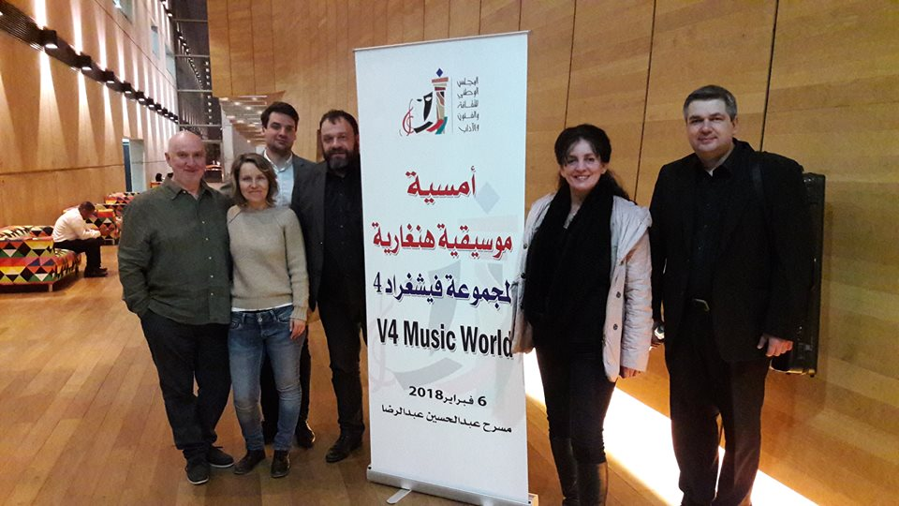
Irén Lovász- V4 Grooveoce Band in Kuwait 2018 (Kornél Horváth, Jitka Suranska, Szczepan Pospieszalski, Irén Lovász, Sztano Palúch)
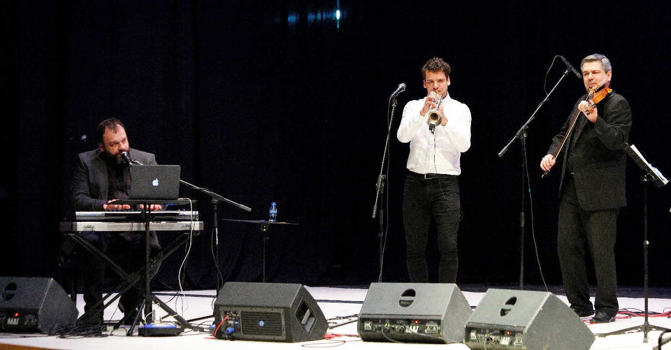
Zoltán Mizsei (H), Szczepan Pospeszalski (PL), Stanislav Palúch ( SK) in Kuwait 2018.

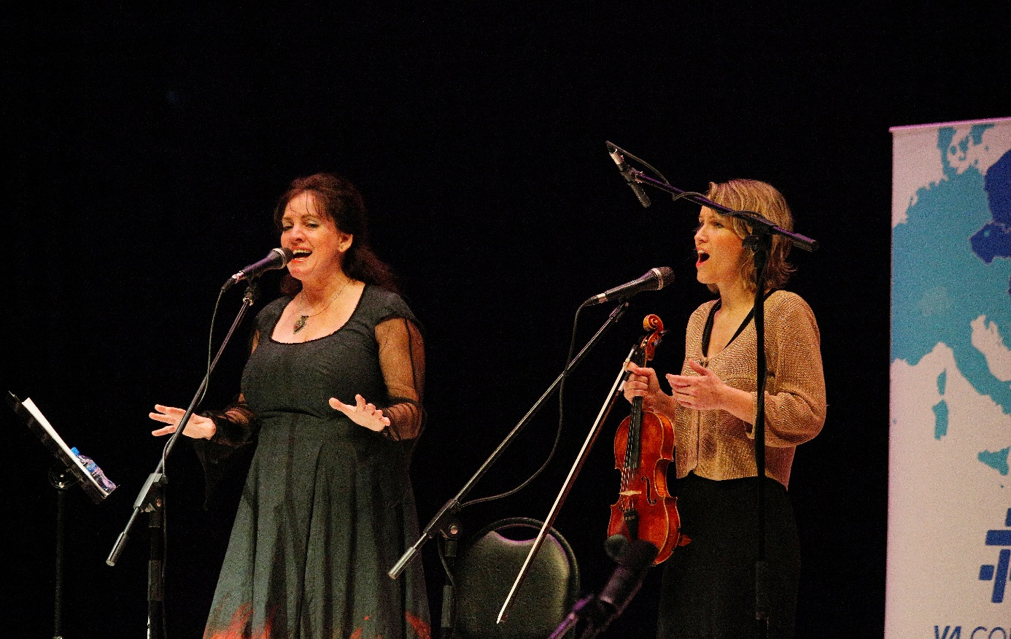
Irén Lovász(HU) and Jitka Suranska(CZ) in Kuwait 2018.
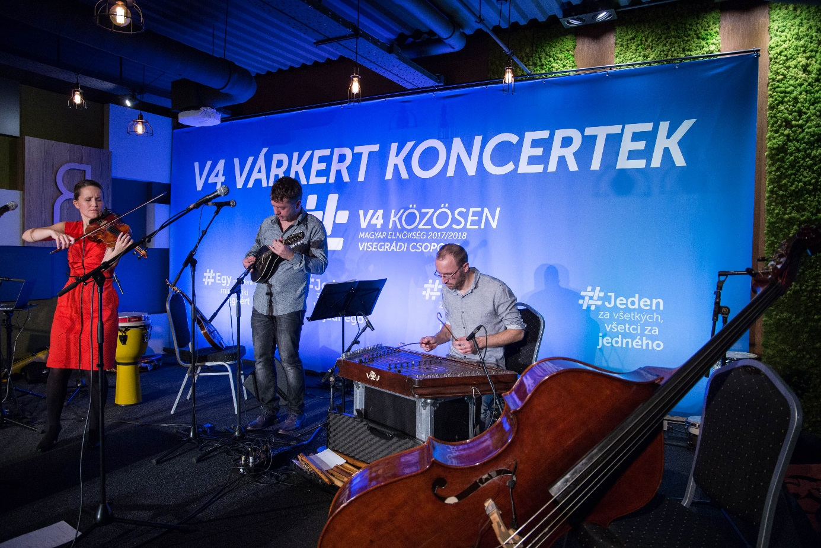
Martin Krajicek with Jitka Suranska Trio(CZ) in Budapest V4 Concerts 2017.
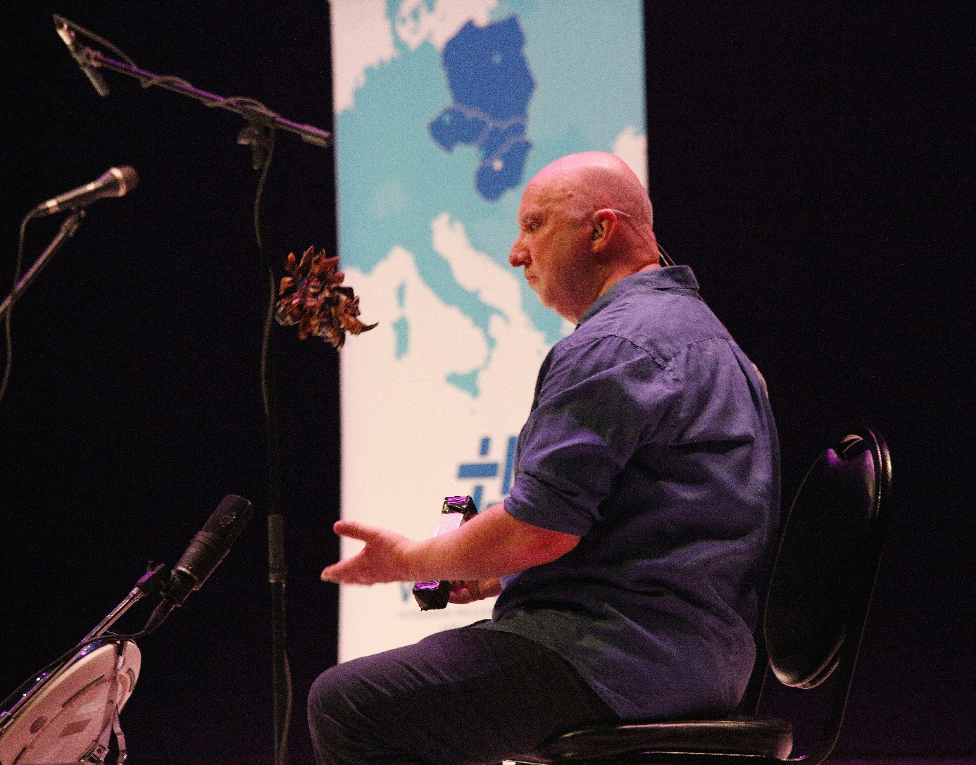
Kornél Horváth(HU) in Kuwait 2018.
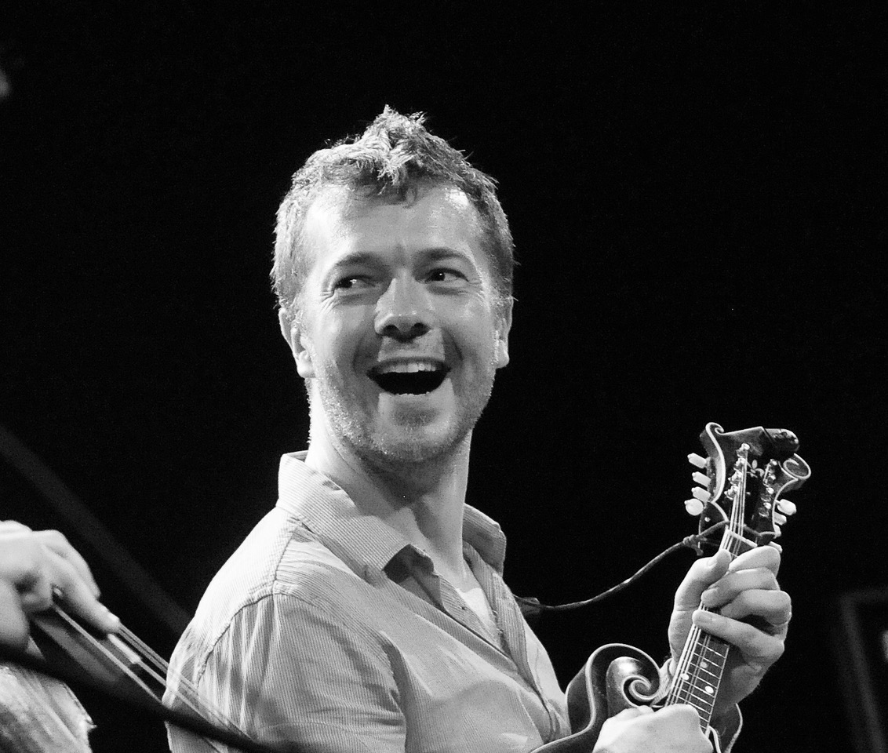
Martin Krajíček (CZ)

Szczepan Pospieszalski (PL) in Kuwait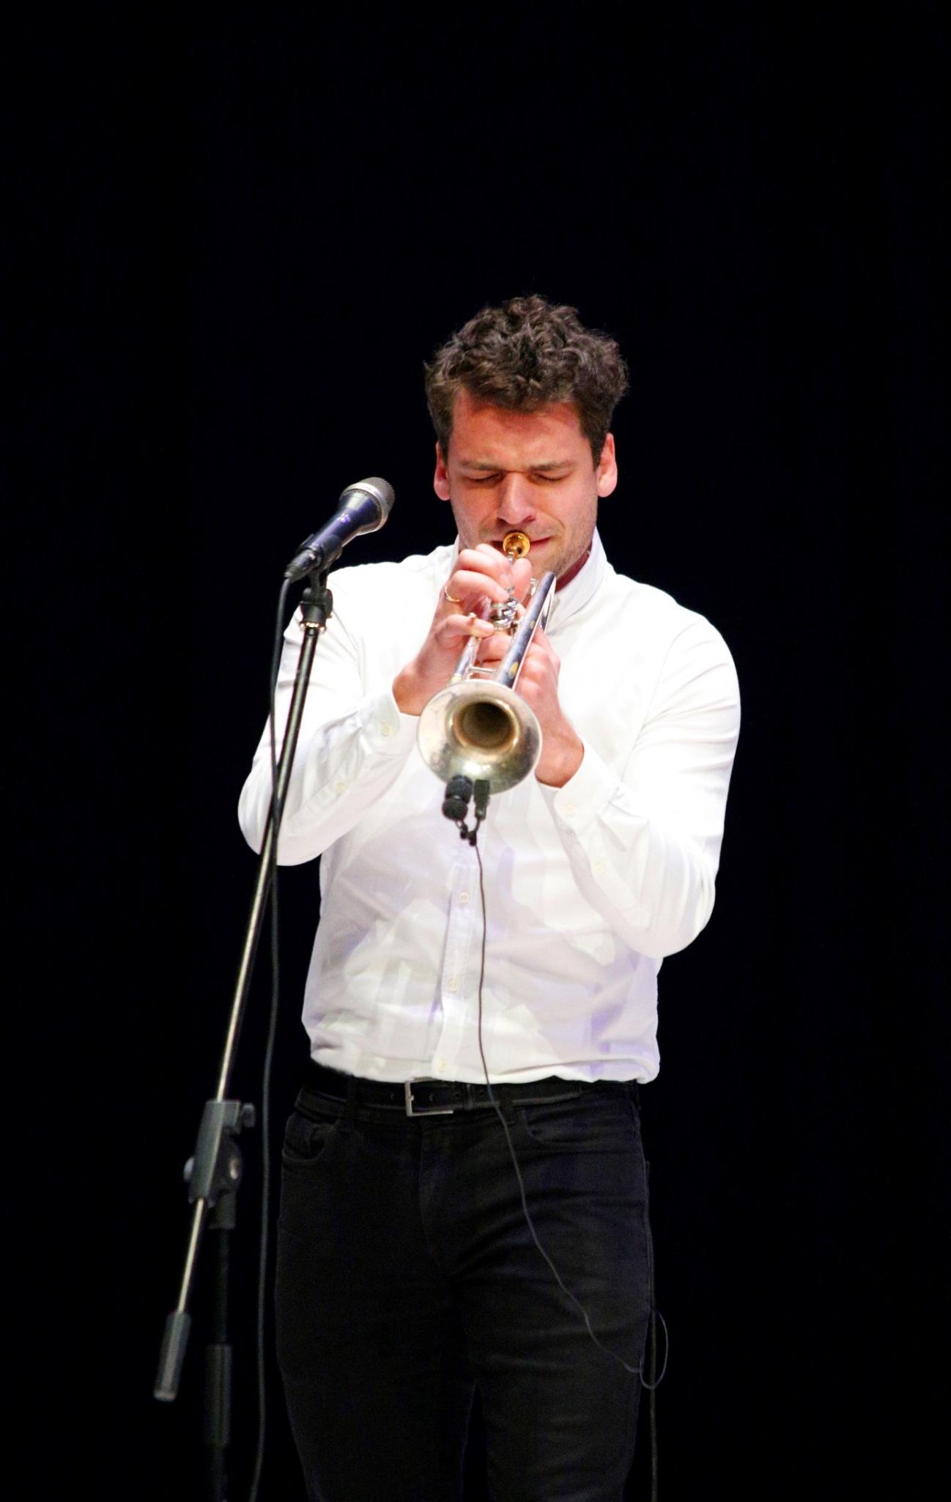
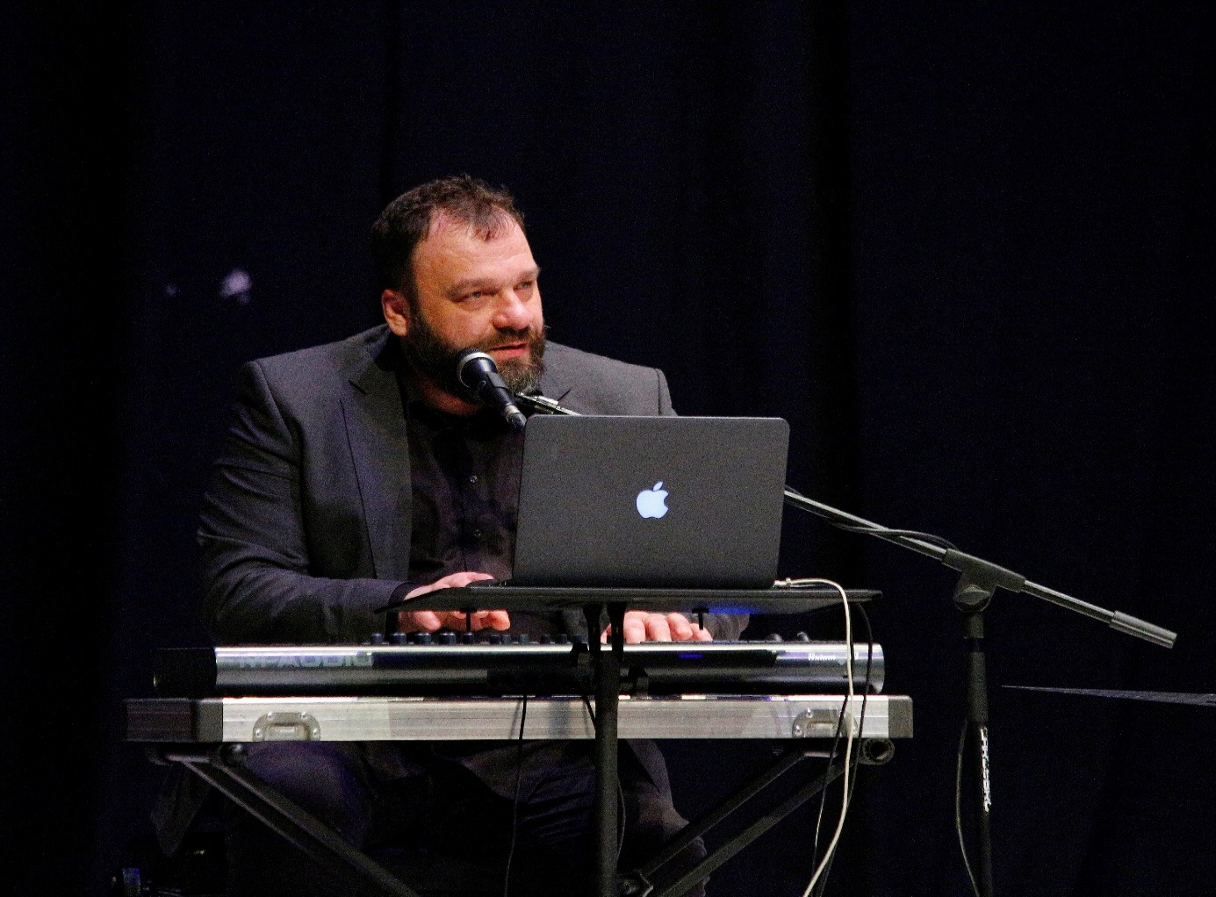

Zoltán Mizsei (H) in Kuwait 2018.
Byla cesta:
https://www.instagram.com/p/Be3QKpUl3Ha/
Now playing V4 Voice and Groove Band. V4 cooperation really put into practice, a Czech song sung by Hungarian singers accompanied by Polish, Slovakian, Czech players!
Za vodu:
https://www.youtube.com/watch?v=nLxkQ_7G9bY&list=OLAK5uy_lYT3Xa5zggggmBTl2F-BBGKBYO7fRmsnw&index=9

Szánom, bánom: https://www.youtube.com/watch?v=qVN9QjgKTsU&list=OLAK5uy_lYT3Xa5zggggmBTl2F-BBGKBYO7fRmsnw&index=2
Indulj el egy úton:
https://www.youtube.com/watch?v=QopuLjNBpHA&list=OLAK5uy_lYT3Xa5zggggmBTl2F-BBGKBYO7fRmsnw&index=7
Wide is the Danube:
https://www.youtube.com/watch?v=e6kC_IH49c8
Verjen meg:
https://www.youtube.com/watch?v=c2TypEMdyZ8
Ének a határtalanról:
https://www.youtube.com/watch?v=CWEj13mjbxc
A tűz színe/ Colours of fire
https://www.youtube.com/watch?v=ADjZo-lJuHo

